**Status Report**

List of programs. Clearly describe the problem that you are solving. Please put the date that you worked on it:

<https://github.com/DavidPeet8/Grade-12-game>

David: Random World Generation (Feb 7 - now)

* randomly generate a 2D terrain
* Use Perlin Noise to create organic look and feel to terrain
* store map in json file so we do not run into memory issues
* seed the noise function
* Draw array of boxes under the top terrain layer
* Randomize the block type under surface layer intelligently
* Scale values based on tile width and height
* Draw map to screen based on players position using orthographic camera

Basic Architecture(Feb 5 to Feb 7)

* Use Kerians code set up screen based project
* Use idea of multiple packages

Matthew:

* Basic gravity (February 5)<https://github.com/DavidPeet8/Grade-12-game/tree/master/core/src/gdx/game/ScrGravity>
  + Loaded GravityWithoutBox2d scratch from last year into Kieran’s template
  + Moved more of the functionality into Sprite2 class instead of changing Sprite2 variables in main.
* The Perfect Platform (February 12ish) <https://github.com/DavidPeet8/Grade-12-game/tree/master/core/src/gdx/game/ScrBetterHitDetection>
  + Created a Side class that the Sprite2 class
  + Moved more of the functionality into Sprite2 class instead of changing Sprite2 variables in main.

Major Challenges/setbacks( reference specific code please):

David: - Having trouble finding out if/how to write to a index in a pre existing json object (ScrLoad, lines 81-93)

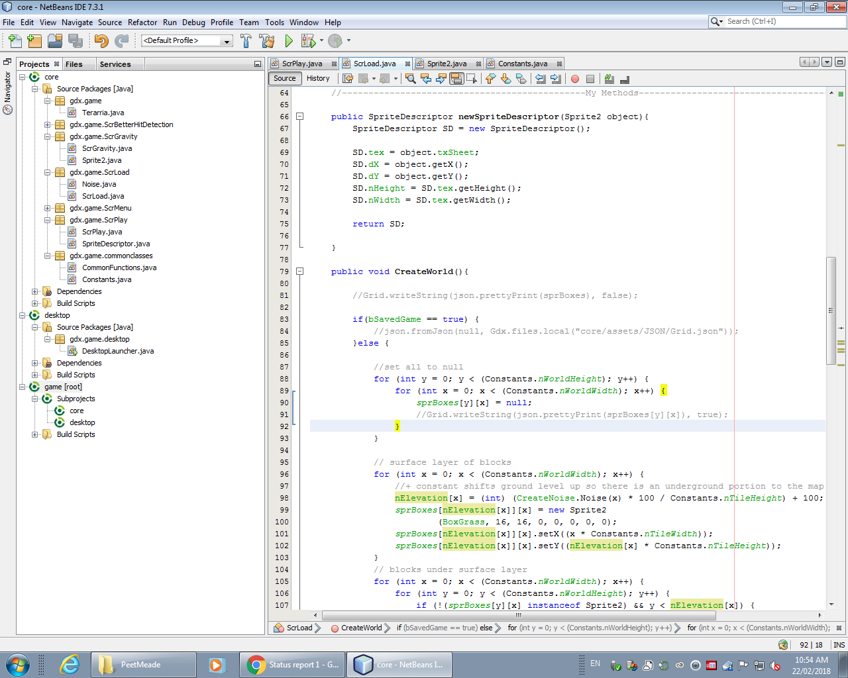

* Trouble finding code for 1D noise, Using 2D noise is a waste of resources (Noise)
* Memory problem when we attempt to load too many tiles, run out of RAM (ScrLoad, line 98)

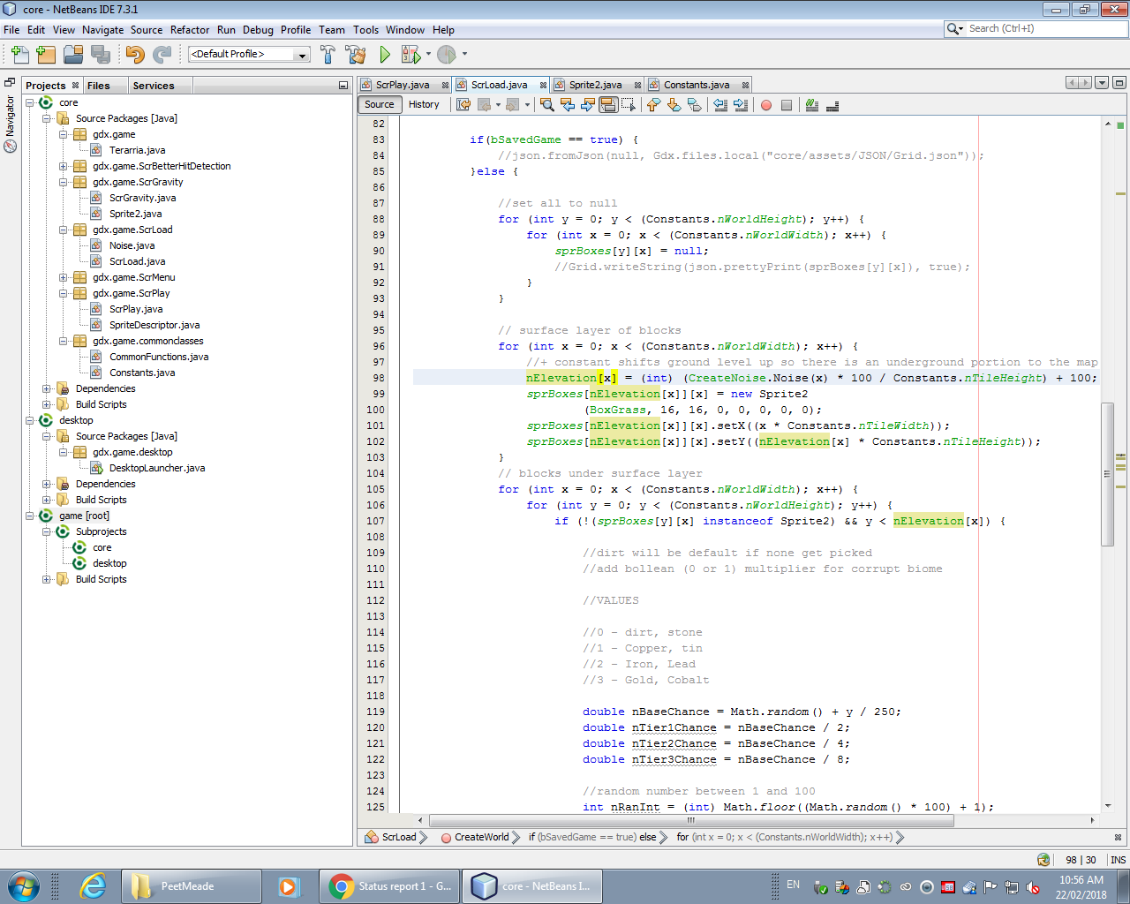

* Odd issue drawing sprite need to call super() with texture inside it for sprite to actually draw, must initialize parent class constructor (ScrGravity, Sprite2, line 22)

Matthew:

* Had trouble loading old LibGDX code into Kieran’s template with gravity because I was missing assets.
* Trial and error of the best way to set up the Sides took longer than expected.

Source any web site/book that helped you with that concept:

David:

* <https://stackoverflow.com/questions/41896919/java-lang-nullpointerexception-when-spritebatch-end-occurs>
* <https://stackoverflow.com/questions/22802572/write-to-json-using-libgdx>
* <http://freespace.virgin.net/hugo.elias/models/m_perlin.htm>
* <https://www.redblobgames.com/maps/terrain-from-noise/>
* <https://www.redblobgames.com/articles/noise/introduction.html>
* <https://www.tutorialspoint.com//java/util/java_util_random.htm>
* <https://www.michaelbromley.co.uk/blog/simple-1d-noise-in-javascript/>

Describe the code and the lesson that you learned from it:

David: My program makes use of a 1D perlin noise function I converted from javascript that I found on <https://www.michaelbromley.co.uk/blog/simple-1d-noise-in-javascript/>. It takes noise values and maps them to y values in my 2D array of tiles that creates my map. I then draw blocks at the corresponding y values to create the surface layer of my map. The program will proceed to populate all array spaces under that line with stone blocks. In the future I would like those blocks to be intelligently random, and to store the map in a json file. I learned how to interact with a piece of code I do not fully understand and still achieve my goal, as well as many lessons on efficiency, and that primitive data types cannot be null, only objects may hold null.

Matthew: My part of the program (<https://github.com/DavidPeet8/Grade-12-game/tree/master/core/src/gdx/game/ScrBetterHitDetection>) has a player and a wall which are both Sprite2’s. Both of them have 4 Sides. Gravity acts on the player and the player can jump around. There is hit detection between the player and the wall followed by a hit test between different combinations of Sides. Depending on what the hit test returns the player responds differently. There is a slight “jump” if you fall against the side of the platform, but that stops a worse bug and isn’t awful so I kept it.

With each status report, you will be submitting EVERYTHING. Organization is key. When I go to the groupwork folder**, I should see your project submitted in the following format:**

YourLastName: Under this folder will be the following folders:

**Documents**: It will hold all of your documents: status report, list of sources, and all the other documents that will be submitted in your final project.

**Programs**: There will be a folder for each project.